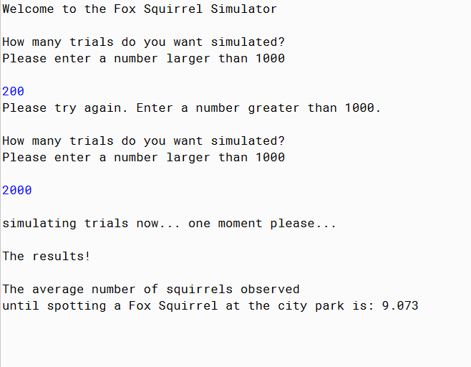

PMR: this program was quite simple to build. With help of google and other examples it was easy to follow along the basic outline to create this program. I enjoyed building and tweaking this program.

/\*\*

\* The class AnimalPopulation uses the Monte Carlo sampling method to

\* estimate the average number of animals observed before spotting one

\* you are tracking within a particular ecosystem.

\*

\* @Anika Jallipalli

\* @10/30/2019

\*/

import java.util.Scanner;

import java.io.File;

import java.io.IOException;

import java.io.PrintWriter;

public class AnimalPopulation

{

public static void main(String [] args) throws IOException

{

System.out.println("");

System.out.println("Welcome to the Fox Squirrel Simulator");

System.out.println("");

Scanner input = new Scanner(System.in);

//opening a file to storage data

PrintWriter outFile = new PrintWriter(new File("animalPopulation.txt"));

int trial = 0;

double sum = 0;

// get number of trials which is at least 1000

while (trial < 1000)

{

System.out.println("How many trials do you want simulated?");

System.out.println("Please enter a number larger than 1000");

System.out.println("");

trial = input.nextInt();

if (trial < 1000)

System.out.println("Please try again. Enter a number greater than 1000.");

System.out.println("");

}

//System.out.println(trial);

//assigning a number to animal

int animal = 8;

for(int counter = 0; counter < trial; counter++)

{

int randAnimal = (int) (Math.random() \* 9) + 1;

int count = 1;

while (randAnimal != animal)

{

randAnimal = (int) (Math.random() \* 9) + 1;

count++;

}

outFile.println(count);

}

outFile.close ( ); //closing file

//opening file for processing

File fileName = new File("animalPopulation.txt");

Scanner inFile = new Scanner(fileName);

int token = 0;

String tokenString;

//calculating sum

while( inFile.hasNextLine() )

{

tokenString = inFile.nextLine( );

token = Integer.parseInt(tokenString);

sum = sum + token;

}//end while

System.out.println("simulating trials now... one moment please...");

System.out.println("");

double avg = sum/trial;

//System.out.println("sum =" + sum);

//System.out.println("t =" + trial);

System.out.println("The results!");

System.out.println("");

System.out.println("The average number of squirrels observed ");

System.out.println("until spotting a Fox Squirrel at the city park is: " + avg);

System.out.println("");

inFile.close(); //close input file

}

}